There is something new for members!

Members with an iPhone can download the IEHA membership app. The android version will be released soon.

Here is what you can do with the member app:
- View a member directory
- View a member's profile
- Email their fellow members
- View an event calendar and event details
- Register for an event
- Specify the number of guests (if the registration type was set up to collect the total number of guests only)
- View their existing event registrations
- Pay an outstanding event registration fee
- View their member profile

What can't your members do with the member app?
- Delete existing event registrations
- View session dates for multi-session events
- Update their member profiles

Downloading the member app is easy:
To download the Wild Apricot member app for iOS, click here.

Logging in
When you first open the member app, you will be asked to agree to the terms of use. Next, you will be asked to log in using the same email address and password you use to access your desktop computer version.
Member App Settings
To access the member app settings, hover over the Settings menu and click the Member app option. Once you are finished changing the settings, click Save settings.
The following settings are available:
Enable member app
Controls whether the member app is available to your members.
Show member directory
Controls whether a member directory appears on the member app. If you enable the member directory, you can choose the kinds of members you want to appear in the directory.
Members to include
If you've chosen to show the member directory on the member app, you can choose the kinds of members you want to appear in the directory. You can choose from one of the following options:
- All active members
- Members drawn from one of your saved searches
- Members who belong to the membership levels you choose
Show bundle administrators only
If you have bundle membership levels, you can choose to show just bundle administrators in your member directory and not bundle members.
Show events calendar
Controls whether an event calendar appears on the member app. If you enable the events calendar, you can choose the kinds of events you want to appear on the calendar.
Events to include
If you've chosen to show the events calendar on the member app, you can choose the kinds of events you want to appear on the calendar. You can choose:
- All public events
- Public events with any of the event tags you select

Navigating the member app
Depending on your settings, the Wild Apricot member app can consist of the following modules: Members, Events, My tickets, Profile. To jump between these modules, tap the module name at the bottom of the screen.
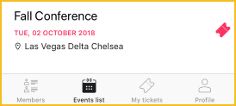

Viewing the member directory
Unless you have disabled it within your member app settings, members can view your member directory by tapping Members at the bottom of the screen.
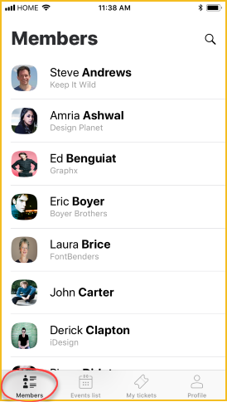
If you want a photo to appear for each member, create a picture field as a common field or membership field and name it Photo.
Within your app settings, you can control which kinds of members appear within the directory. Members who have set their profiles to private within their privacy settings will not appear regardless of your settings.
Tapping on a member within the directory will display that member's profile (subject to their privacy settings).
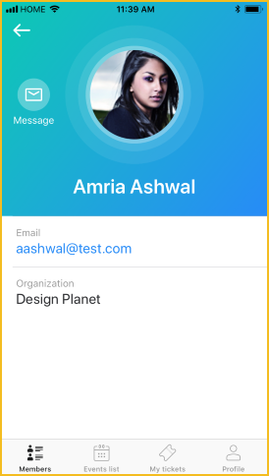
To send an email message to the member, tap Message beside the member's photo.
The Message option will appear if the member's privacy settings is set to display the Send message form, even if the member's email address is hidden.

Viewing the events list
Unless you have disabled it within your member app settings, members can view an event calendar showing upcoming events by tapping Events list at the bottom of the screen.
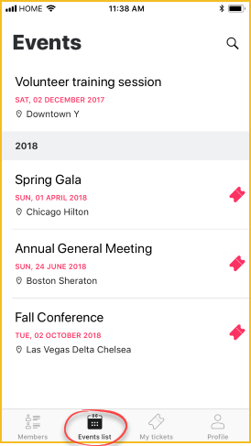
Tapping any of the events within the list will display the details of that event.
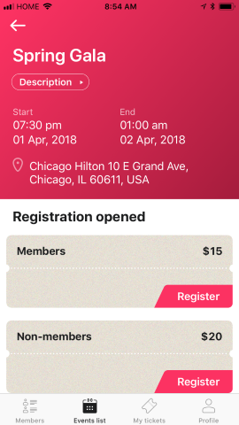
Tapping on the location within the event details will display the location within your Maps app.
Members can register for the event by tapping the Register button beside the appropriate registration type. The registration form will appear, along with options to specify the number of guests and indicate whether the registrant wants to appear within the public list of event registrants.
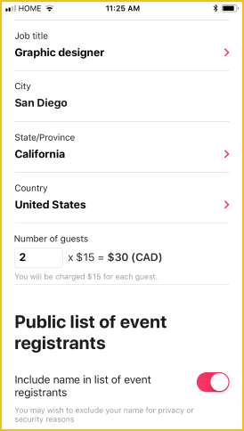
The registrant cannot register guests if the registration type was set up to collect contact information or full registration information.
Once they complete the registration form and tap Continue, their payment options will appear. Depending on the payment method chosen when the event was set up, members might see Invoice meand/or Pay online buttons.
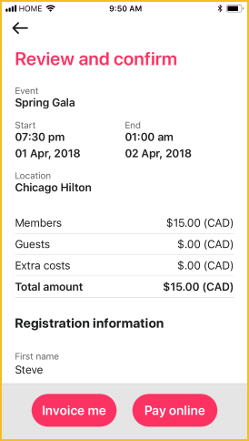
Once they click a payment option and complete the registration, their registration will appear on the My tickets screen.

Viewing event tickets
Members can view their existing event registrations by tapping My tickets at the bottom of the screen.
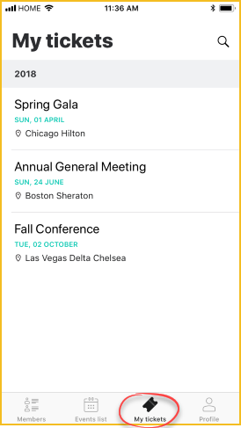
Tapping one of the registrations within the list will display the event registration details.
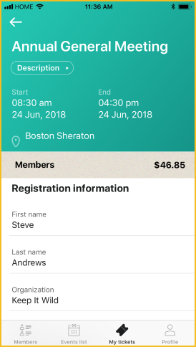
If the event registration fee is not fully paid, members can tap the Pay button to pay the fee online.
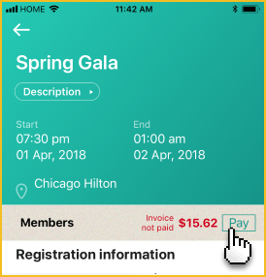

Viewing your profile
Members can view their own member profile by tapping Profile at the bottom of the screen.
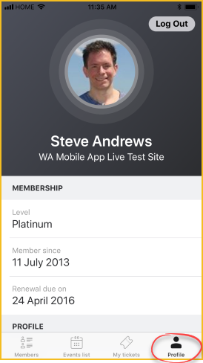
From their member profile, members can log out of the app by tapping Log out.

Adding an app banner to your site
To alert your members to the Wild Apricot member app, you can add an official banner to the mobile version of your site that links to the member app page on Apple's App Store.
To add the app banner to your site, follow these steps:
- Under the Settings menu, click Site.
- Within the Site settings screen, click Meta-tags.
- In the Raw Headers section, paste the following code:
<meta name="apple-itunes-app" content="app-id=1220348450">
- Click Save button to save your changes.
The banner will appear on your site only when it is viewed on an iOS device using the Safari browser.

